**Milestone 6**

**Student Hub**

Team Members

* Neerav Poriya
* Vidisha Sawant
* Prashant Shinde
* Raj Mehta

# Introduction

We are aware that being an international student is challenging. Please allow us to assist you by giving you answers to the most frequent questions asked by students. We really hope that this website will meet your needs.

We have developed this web application into two parts, features that are common and are not university centric are placed directly on the homepage and second part consists of university centric features which you will see while doing this testing. The features you will see will consist of frequently asked ones and most common problems faced by international students.

# Evaluation Process

We conducted the interview via Zoom for the incoming students and on Campus interview for the students who are already here in a moderated way.

Neerav provided the walkthrough and conducted task and Vidisha was the note taker. Prashant was also there to check if any Figma link break then to fix it.

**Performed Tasks**

# Zoom Participants (In coming)

|  |  |  |  |  |
| --- | --- | --- | --- | --- |
| **Kshitij Sharma** | Time Taken  Website | Time  Taken  Mobile | False Steps | Errors |
| How will you find Mentor details related to the CS stream for the Graduate Program? | 00:50 | 00:20 | None | Mentorship program? |
| How do I get details about red flags related to accommodation? | 00:10 | 00:07 | None |  |
| Where can I get details about Exchange Place which is very famous among Tourists? | 00:15 | 00:06 | None |  |
| How will you find link to apply for on Campus jobs for Pace University? | 00:15 | 00:12 | None |  |

Feedbacks and Comments:

* What is mentorship program?
* I believe mobile and website can have different looks till the time it is functional and doing the work accurately.

|  |  |  |  |  |
| --- | --- | --- | --- | --- |
| **Mrudul Ghaghor** | Time Taken  Website | Time  Taken  Mobile | False Steps | Errors |
| How will you find Mentor details related to the CS stream for the Graduate Program? | 00:45 | 00:22 | None |  |
| How do I get details about red flags related to accommodation? | 00:15 | 00:06 | None |  |
| Where can I get details about Exchange Place which is very famous among Tourists? | 00:22 | 00:10 | None |  |
| How will you find link to apply for on Campus jobs for Pace University? | 00:15 | 00:09 | None |  |

Feedbacks and Comments:

* Mentorship program is something new and I had no clue that university has such program, good to know it and this is informative.
* I believe mobile and website should look same in look and feel wise.

|  |  |  |  |  |
| --- | --- | --- | --- | --- |
| **Aishwarya Nair** | Time Taken  Website | Time  Taken  Mobile | False Steps | Errors |
| How will you find Mentor details related to the CS stream for the Graduate Program? | 01:00 | 00:22 | None |  |
| How do I get details about red flags related to accommodation? | 00:15 | 00:06 | None | What do we mean by red flag? |
| Where can I get details about Exchange Place which is very famous among Tourists? | 00:22 | 00:10 | None |  |
| How will you find link to apply for on Campus jobs for Pace University? | 00:15 | 00:09 | None |  |

Feedbacks and Comments:

* Why do we have this chatbot feature when we have same bubbles outside. (On explaining, that chatbot will also have non prominent features and bubbles that are not already covered and if you feel like we missed something, you can convey the same to us) agreed the use of it.
* I believe mobile and website should look the same, yes less information to display on mobile upfront but design wise they should be same.

# On Campus Interviews

|  |  |  |  |  |
| --- | --- | --- | --- | --- |
| **Neha Chudekar** | Time Taken Website | Time  Taken  Mobile | False Steps | Errors |
| How will you find Mentor details related to the CS stream for the Graduate Program? | 00:25 | 00:20 | None |  |
| How do I get details about red flags related to accommodation? | 00:10 | 00:07 | None |  |
| Where can I get details about Exchange Place which is very famous among Tourists? | 00:15 | 00:06 | None |  |
| How will you find link to apply for on Campus jobs for Pace University? | 00:15 | 00:12 | None |  |

Feedbacks and Comments:

* Felt that major points were covered.
* Would like to have the loan feature bubble prominent.

|  |  |  |  |  |
| --- | --- | --- | --- | --- |
| **Aishwarya Suresh** | Time Taken  Website | Time  Taken  Mobile | False Steps | Errors |
| How will you find Mentor details related to the CS stream for the Graduate Program? | 00:20 | 00:18 | None |  |
| How do I get details about red flags related to accommodation? | 00:15 | 00:11 | None |  |
| Where can I get details about Exchange Place which is very famous among Tourists? | 00:25 | 00:10 | None |  |
| How will you find link to apply for on Campus jobs for Pace University? | 00:20 | 00:15 | None |  |

Feedbacks and Comments:

* Felt that major points were covered.
* Wanted transfer money to India feature bubble.
* Wanted paying money to university feature.

|  |  |  |  |  |
| --- | --- | --- | --- | --- |
| **Vivek Brijwasi** | Time Taken  Website | Time  Taken  Mobile | False Steps | Errors |
| How will you find Mentor details related to the CS stream for the Graduate Program? | 00:25 | 00:18 | None | For which university? |
| How do I get details about red flags related to accommodation? | 00:12 | 00:07 | None |  |
| Where can I get details about Exchange Place which is very famous among Tourists? | 00:20 | 00:11 | None |  |
| How will you find link to apply for on Campus jobs for Pace University? | 00:20 | 00:15 | None |  |

Feedbacks and Comments:

* Like the application and wants it to be implemented.

# During the Task Questions

While conducting the task and giving the walkthrough, we asked few open-ended questions to understand our users better. Some of the questions are as mentioned below

1. Do you think this design is easy to use?

All the users found the website was intuitive and was easy to use.

1. What do you think about this design?

Most of the liked the design and color selections, but majority believed the website and mobile design should be identical and should follow same look and feel.

1. Do you think places to visit in New York is a useful feature?

They did enjoy the feature and would love to see personal touch to it and user stories, of how they travelled through different places.

# System Usability Scale (SUS)

The SUS score was calculated by the matrix of

* For every odd-numbered question, subtract 1 from the score (X-1)
* For every even-numbered question, subtract the score from 5 (5-X)
* Sum the scores from even and odd-numbered questions. Then multiply the total with 2.5

**Link to SUS survey: https://forms.gle/bWSeJhk7RXSRRZsB8**

|  |  |  |  |  |  |  |  |  |  |  |  |  |  |
| --- | --- | --- | --- | --- | --- | --- | --- | --- | --- | --- | --- | --- | --- |
|  | 1 | 2 | 3 | 4 | 5 | 6 | 7 | 8 | 9 | 10 |  | SUS Raw Score | SUS Final Score |
| User 1 | 5 | 1 | 5 | 5 | 5 | 2 | 5 | 1 | 5 | 1 | 5 | 35 | 87.5 |
| User 2 | 4 | 1 | 4 | 1 | 5 | 1 | 4 | 1 | 4 | 1 | 5 | 36 | 90 |
| User 3 | 4 | 1 | 5 | 1 | 4 | 2 | 5 | 1 | 5 | 1 | 4 | 37 | 92.5 |
| User 4 | 5 | 1 | 5 | 2 | 5 | 1 | 5 | 1 | 5 | 2 | 5 | 38 | 95 |
| User 5 | 3 | 1 | 4 | 2 | 4 | 1 | 5 | 1 | 5 | 1 | 5 | 35 | 87.5 |
| User 6 | 4 | 1 | 5 | 1 | 5 | 1 | 5 | 1 | 5 | 1 | 5 | 39 | 97.5 |

**SUS Results**

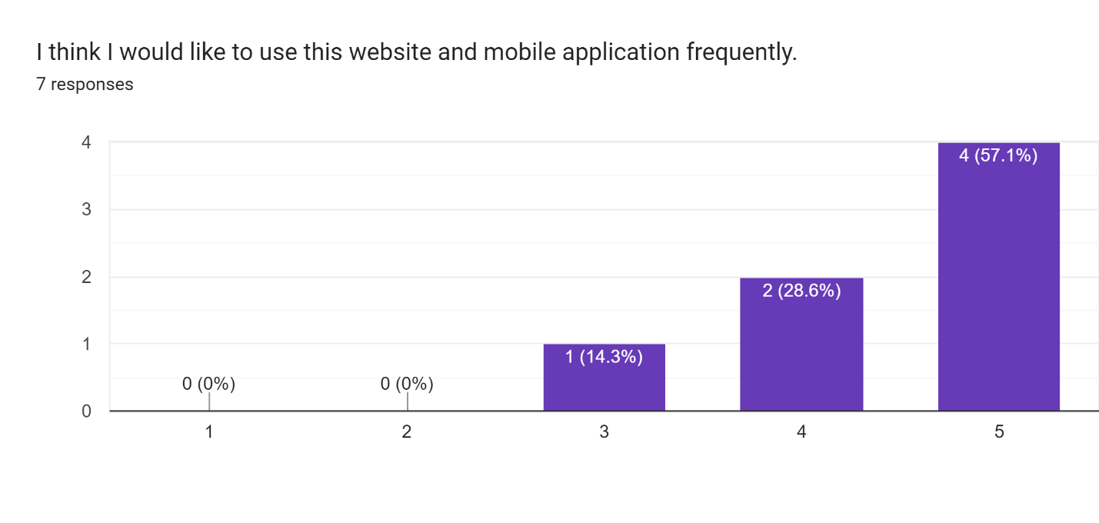

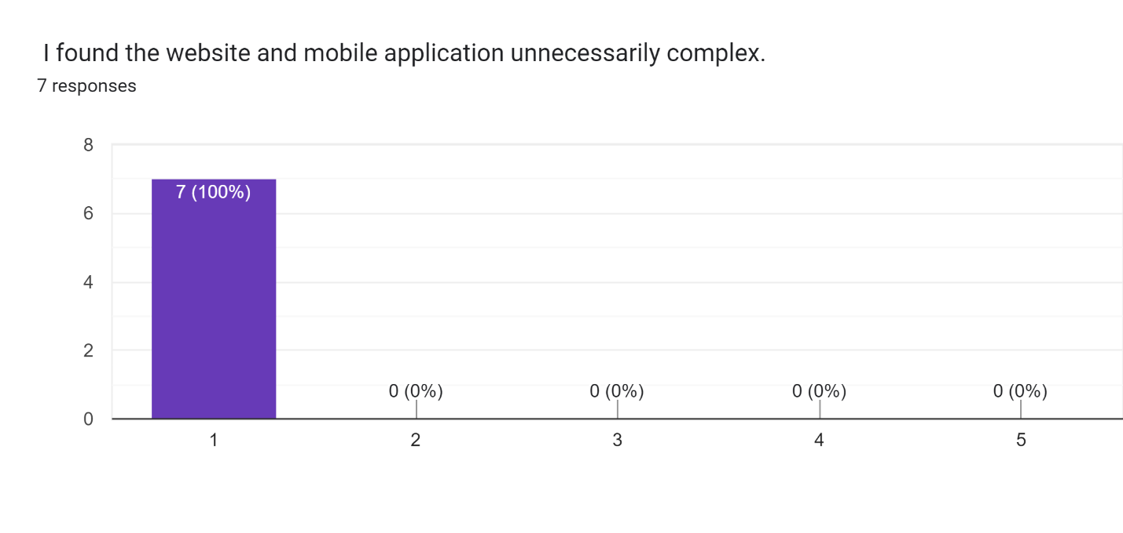

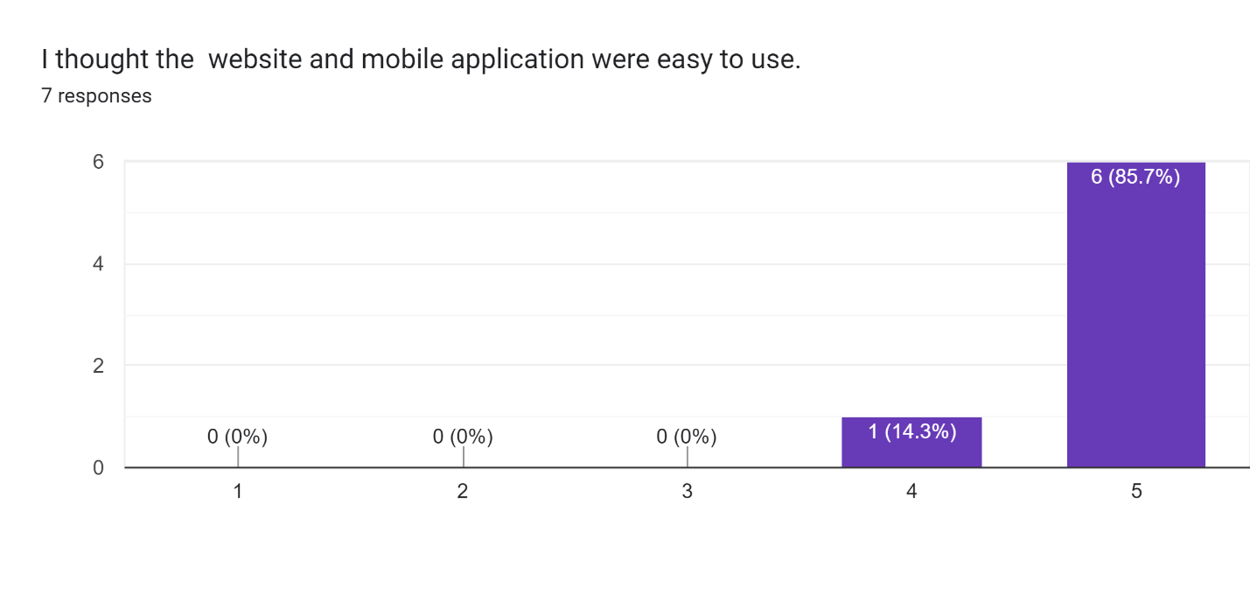

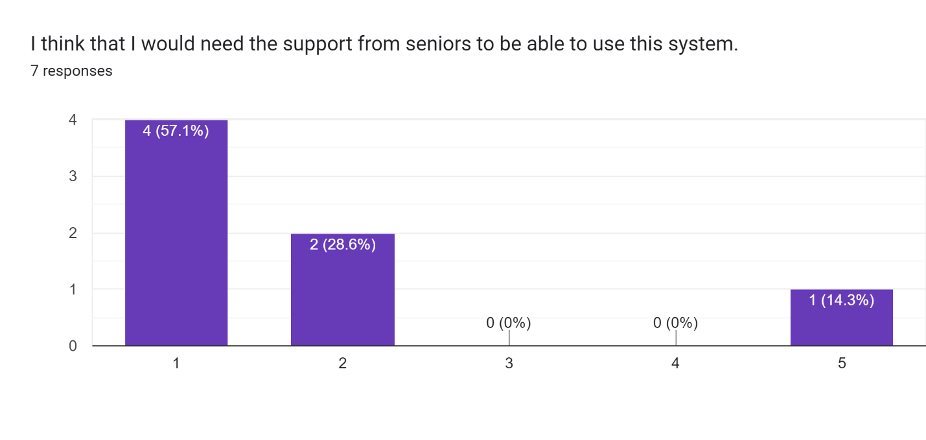

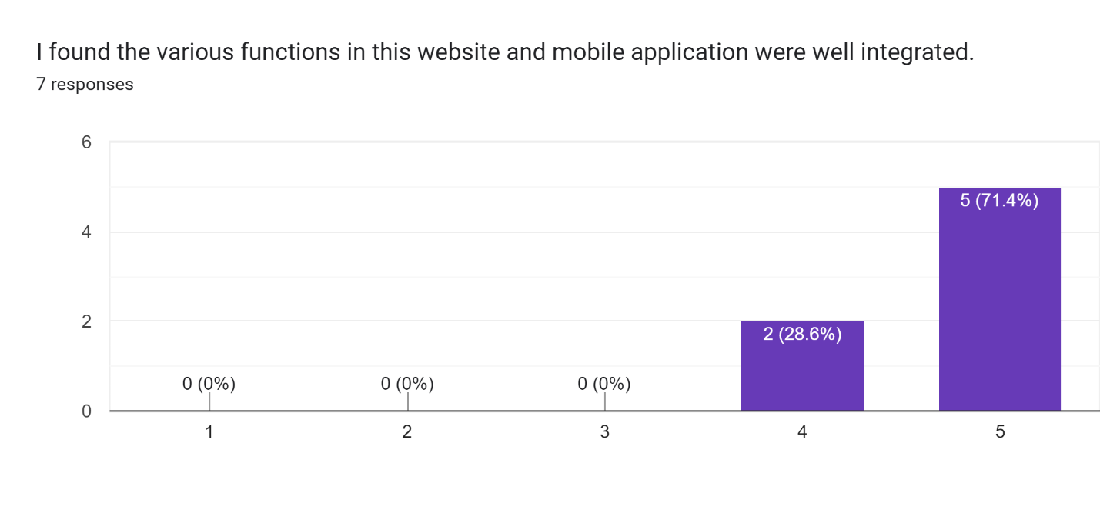

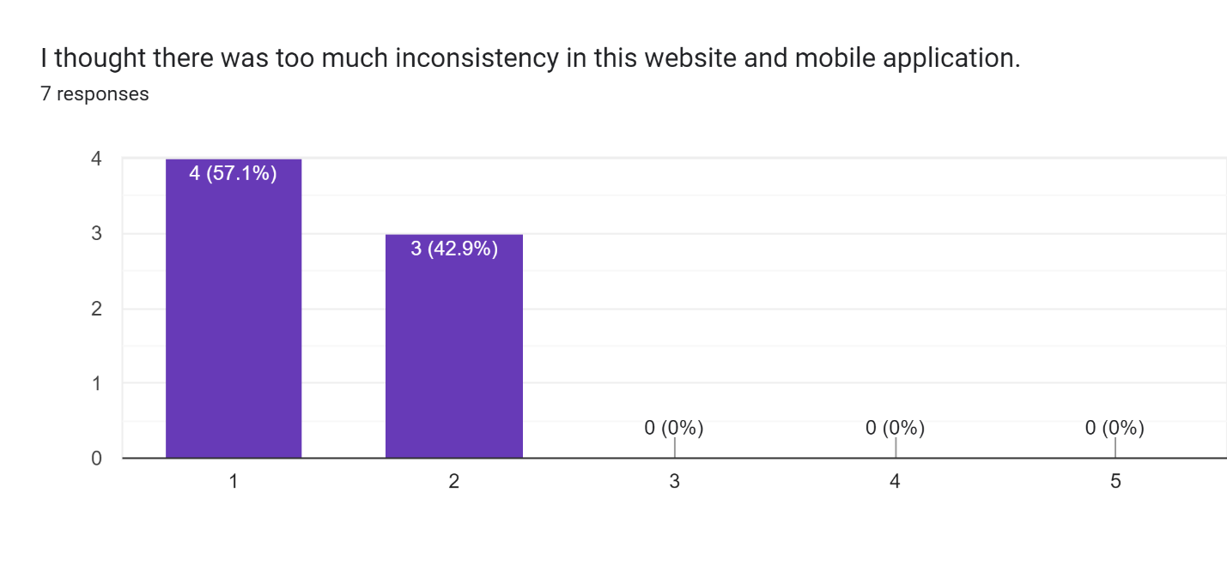

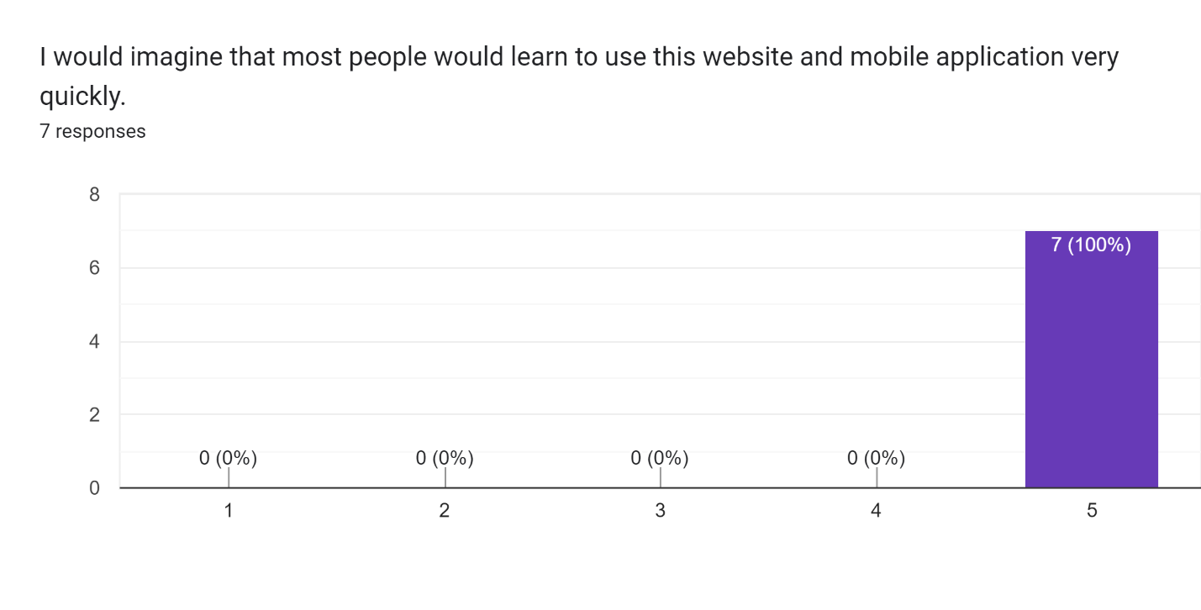

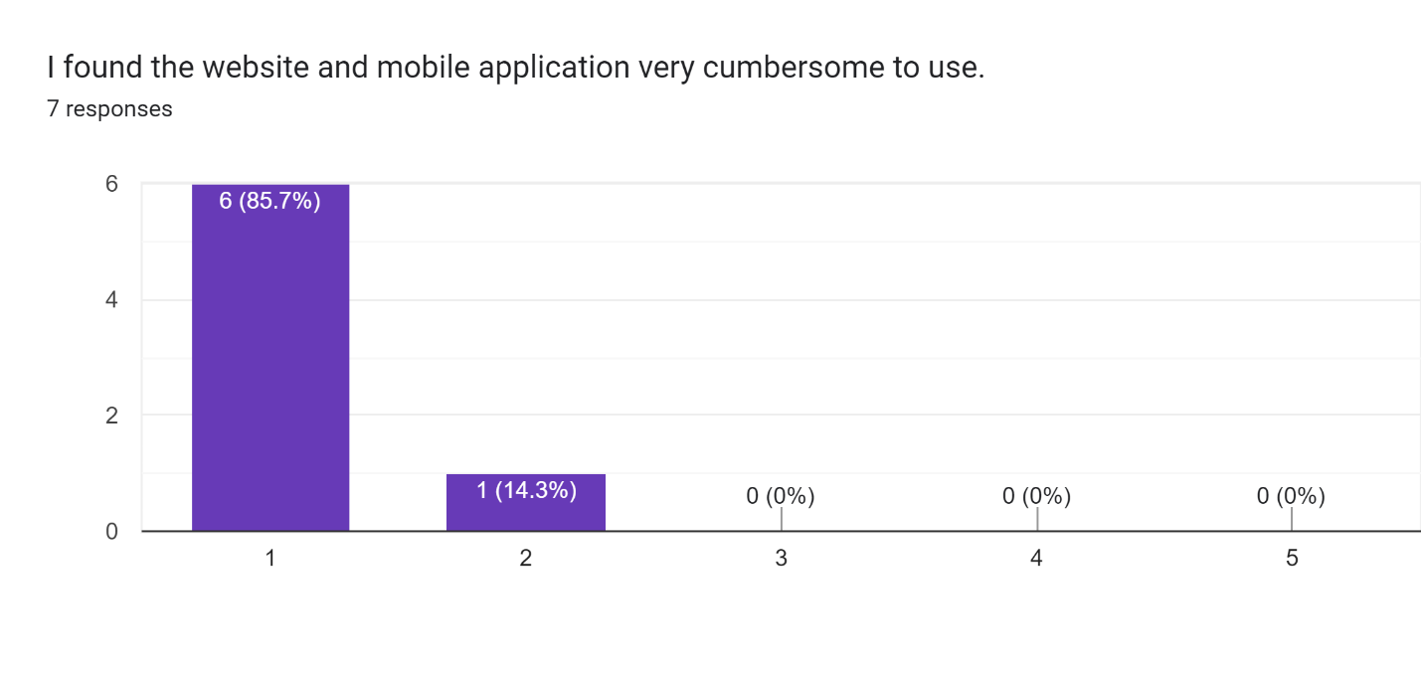

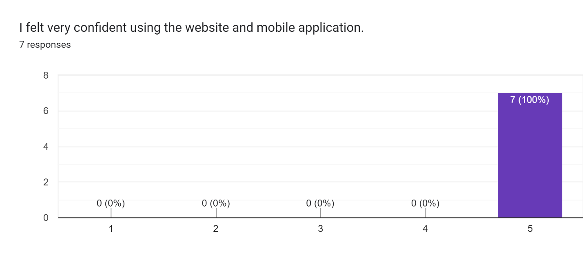

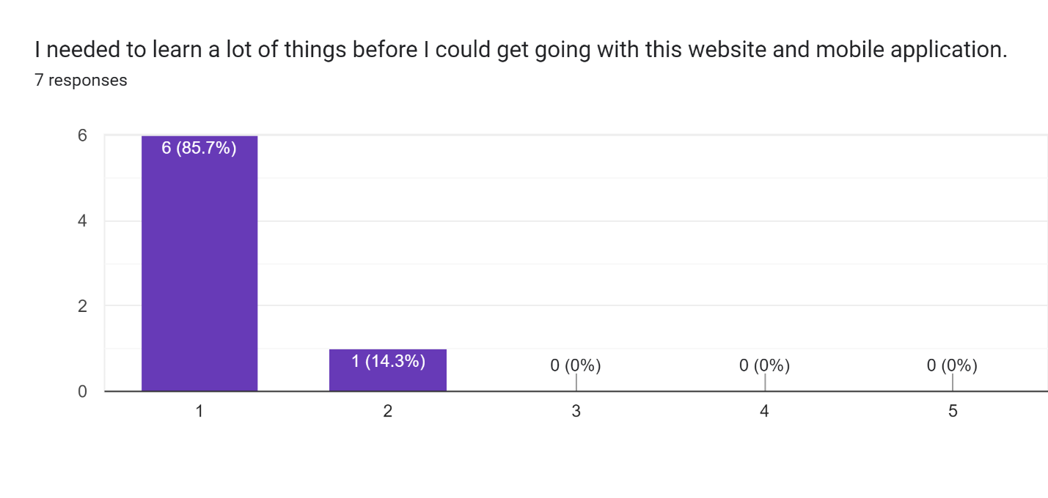

We asked an additional question, just to understand whether users will be using our website or no

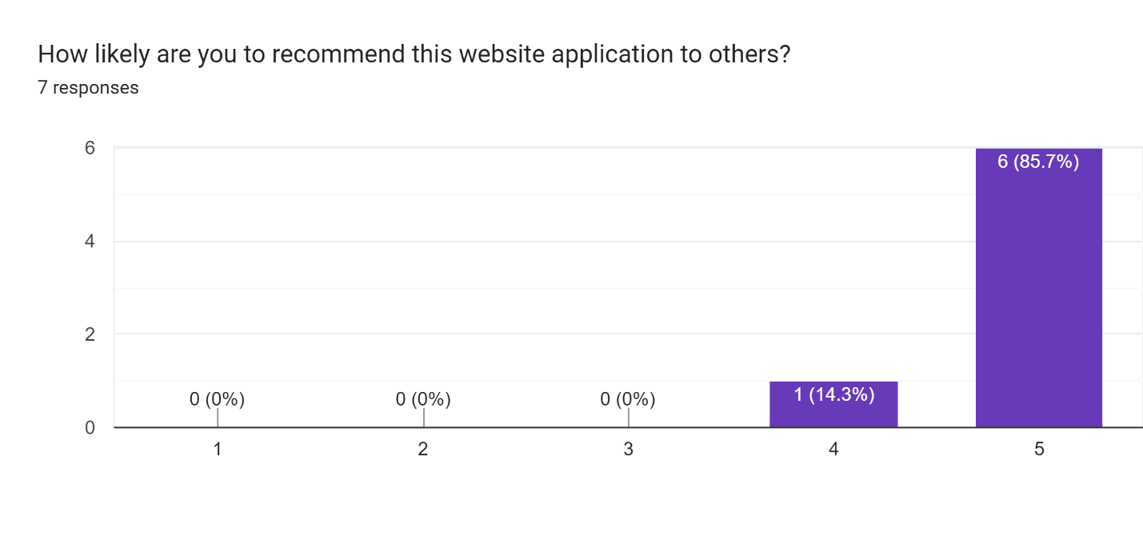

# Questions that were covered during the interview

We did try and ask open-ended questions and on the scale of 1 to 5 questions to gauge in users’ perspective and to accurately understand their perspective.

Some of the question just to understand are as mentioned below.

**General information and contextual questions**

1. How do you usually search for information about studies abroad?
2. Are you able to find the information you are looking for each time?
3. According to you, how do you categorize the information related to studying abroad?
4. How to feel about sharing your experience with us about you moving to the US for your master’s?

**Usability Questions**

1. Scenario: starting from the homepage – Walk me through what you see on this page?
2. Scenario: starting from the university homepage – Walk me through what you see on this page?
3. Look at the top navigation bar, what do you think you would see on those buttons?
4. What do you expect to find on the mentorship program page?
5. What do you expect to find in a chatbot?
6. On the scale of 1 to 5 how would you rate the chatbot feature?

**Questions related to Task**

1. Scenario: Mentor details for CS graduate program – As a first task, can you find the details of the mentor for CS graduate program?

Measure how much time it takes to complete the task.

1. Why did you take this path?

# Overall Feedbacks after questioning and evaluation

All the 6 participants found the website quite intuitive and easy to use and could figure out the assigned task. During the Task and after the walkthrough the prominent feedbacks that we received are as follows.

* Mobile and Website view should be identical (5 out of 6 users stressed on this point), even though the functioning and content were properly placed but they did notice the design change and would like to have similar design carried in the mobile app as well.
* 2 out of the 6 users did find that the information provided in the Opening of Bank Account section was less and needs more details to it, 2 of them also felt that user or personal touch of someone’s experience of doing that thing will explain things in a better way.
  + 3 of them when probed further also mentioned that they would love to see appointment slot booking feature according to banks added in the page.
* State Id / License page: 2 users said that they would love to have a tab feature to select between New Jersey and New York, instead of scrolling to find a particular information.
* 3 of the users didn’t find the chatbot feature that useful, as the same information was available in the bubbles mentioned. But after explaining the feature better that we have less prominent features also mentioned there like Sending money to India and if they don’t find a particular feature they would like to see, then they could write to us, then they felt that it was ok to have the feature.
* User wanted transferring money to university details bubble to be added to main criteria of the bubbles.
* One user wanted Loan process feature to be prominent.

# Findings and Implementation

* We feel that we will try and keep the design same for both website and the mobile view.
* We will try and add Loan Process and Transferring money to university features.
* Try and change State Id and License page according to user’s feedback.
* Try providing appointment booking slot as per banks in Opening bank account section.